Software Design Specification (SDS)

Resume Parser System

Version 1.0

Members:

Haris Ahmed

Syed Huzaifa Ali

Syed Areeb Hussain

Arbaz Hasan

Date: May 5, 2025

For Fundamentals of Software Engineering (FSE) Project

Contents

|  |  |  |  |  |  |  |  |  |  |  |  |  |  |  |  |  |  |  |  |  |  |  |  |  |  |  |  |  |  |  |  |
| --- | --- | --- | --- | --- | --- | --- | --- | --- | --- | --- | --- | --- | --- | --- | --- | --- | --- | --- | --- | --- | --- | --- | --- | --- | --- | --- | --- | --- | --- | --- | --- |
| 0.1 | Document History . | . | . | . | . | . | . | . | . | . | . | . | . | . | . | . | . | . | . | . | . | . | . | . | . | . | . | . | . | . | 2 |
| 0.2 | Distribution List . . | . | . | . | . | . | . | . | . | . | . | . | . | . | . | . | . | . | . | . | . | . | . | . | . | . | . | . | . | . | 2 |
| 0.3 | Document Sign-Off . | . | . | . | . | . | . | . | . | . | . | . | . | . | . | . | . | . | . | . | . | . | . | . | . | . | . | . | . | . | 2 |
| 0.4 | Document Information |  | . | . | . | . | . | . | . | . | . | . | . | . | . | . | . | . | . | . | . | . | . | . | . | . | . | . | . | . | 2 |
| 0.5 | Definition of Terms, Acronyms and Abbreviation | | | | | | | | | | | | | | | | s | . | . | . | . | . | . | . | . | . | . | . | . | . 3 | |
| 0.6 | Introduction . . . . . . . . . . . . . . . . . . . . | | | | | | | | | | | | | | | | . | . | . | . | . | . | . | . | . | . | . | . | . | . 3 | |
|  | 0.6.1 Purpose of Document . . . . . . | | | | | | | | | | | . | . | . | . | . | . | . | . | . | . | . | . | . | . | . | . | . | . | . | 3 |
|  | 0.6.2 Intended Audience . . . . . . . | | | | | | | | | | | . | . | . | . | . | . | . | . | . | . | . | . | . | . | . | . | . | . | . | 3 |
|  | 0.6.3 Document Convention . . . . . | | | | | | | | | | | . | . | . | . | . | . | . | . | . | . | . | . | . | . | . | . | . | . | . | 3 |
|  | 0.6.4 Project Overview . . . . . . . . | | | | | | | | | | | . | . | . | . | . | . | . | . | . | . | . | . | . | . | . | . | . | . | . | 4 |
|  | 0.6.5 Scope . . . . . . . . . . . . . . | | | | | | | | | | | . | . | . | . | . | . | . | . | . | . | . | . | . | . | . | . | . | . | . | 4 |
| 0.7 | Design Considerations . . . . . . . . . | | | | | | | | | | | . | . | . | . | . | . | . | . | . | . | . | . | . | . | . | . | . | . | . | 4 |
|  | 0.7.1 Assumptions and Dependencies | | | | | | | | | | | . | . | . | . | . | . | . | . | . | . | . | . | . | . | . | . | . | . | . | 4 |
|  | 0.7.2 Risks and Volatile Areas . . . . | | | | | | | | | | | . | . | . | . | . | . | . | . | . | . | . | . | . | . | . | . | . | . | . | 4 |
| 0.8 | System Architecture . . . . . . . . . . | | | | | | | | | | | . | . | . | . | . | . | . | . | . | . | . | . | . | . | . | . | . | . | . | 4 |
| 0.9 | Design Strategy . . . . . . . . . . . . . | | | | | | | | | | | . | . | . | . | . | . | . | . | . | . | . | . | . | . | . | . | . | . | . | 5 |
| 0.10 | Detailed System Design . . . . . . . . | | | | | | | | | | | . | . | . | . | . | . | . | . | . | . | . | . | . | . | . | . | . | . | . | 5 |
|  | 0.10.1 Database Design . . . . . . . . | | | | | | | | | | | . | . | . | . | . | . | . | . | . | . | . | . | . | . | . | . | . | . | . | 5 |
|  | 0.10.2 Application Design . . . . . . . | | | | | | | | | | | . | . | . | . | . | . | . | . | . | . | . | . | . | . | . | . | . | . | . | 8 |
| 0.11 | References . . . . . . . . . . . . . . . . | | | | | | | | | | | . | . | . | . | . | . | . | . | . | . | . | . | . | . | . | . | . | . | . | 12 |
| 0.12 | Appendices . . . . . . . . . . . . . . . | | | | | | | | | | | . | . | . | . | . | . | . | . | . | . | . | . | . | . | . | . | . | . | . | 13 |

0.1 Document History

|  |  |  |  |
| --- | --- | --- | --- |
| Version | Name of Person | Date | Description of Change |
| 1.0 | Haris Ahmed | May 5, 2025 | Document Created |

Table 1: Document History

0.2 Distribution List

|  |  |
| --- | --- |
| Name | Role |
| Fizza Mansoor | Supervisor |
| Haris Ahmed | Frontend Developer |
| Syed Huzaifa Ali | Backend Developer |
| Syed Areeb Hussain | Frontend Developer |

Table 2: Distribution List

0.3 Document Sign-Off

|  |  |  |
| --- | --- | --- |
| Version | Sign-off Authority | Sign-off Date |
| 1.0 | Fizza Mansoor | May 7, 2025 |

Table 3: Document Sign-Off

0.4 Document Information

• Category: Information

• Customer: FAST-NU

• Project: Resume Parser System

• Document: Software Design Specification

• Document Version: 1.0

• Status: Draft

• Author(s): Haris Ahmed, Syed Huzaifa Ali, Syed Areeb Hussain

• Approver(s): Fizza Mansoor

• Issue Date: May 5, 2025

• Document Location: To be determined

• Distribution: Advisor, Project Coordinator’s Office (through Advisor)

0.5 Definition of Terms, Acronyms and Abbreviations

• AI: Artificial Intelligence

• PDF: Portable Document Format

• DOCX: Microsoft Word Document

• SRS: Software Requirements Specification

• SDS: Software Design Specification

• REST: Representational State Transfer

• HTTP: Hypertext Transfer Protocol

• HTTPS: Hypertext Transfer Protocol Secure

• JWT: JSON Web Tokens

• ER Diagram: Entity Relationship Diagram

• DFD: Data Flow Diagram

• UML: Unified Modeling Language

0.6 Introduction

0.6.1 Purpose of Document

This Software Design Specification (SDS) provides a detailed design for the Resume Parser System, outlining the system architecture, design strategies, and technical specifi- cations to guide development. It ensures the system meets the requirements specified in the Software Requirements Specification (SRS) and serves as a blueprint for developers, testers, and stakeholders.

0.6.2 Intended Audience

• Project Team: Developers, Designers, Testers

• Stakeholders: Candidates, Recruiters, HR Departments

• Supervisors: Academic or Project Supervisors

0.6.3 Document Convention

• Font: Times New Roman, 12pt

• Headings: Bold, larger font size

• Tables: Used for structured data

0.6.4 Project Overview

The Resume Parser System is an AI-powered web platform designed to streamline job applications and recruitment. Candidates can manage profiles, upload resumes, search for jobs, and track applications, while recruiters can post jobs, parse resumes, and re- view candidates. The system leverages AI for resume parsing, skill extraction, and job matching.

0.6.5 Scope

The system includes candidate and recruiter panels, AI-driven resume analysis, job man- agement, and secure authentication. It excludes payment processing, social media inte- gration, and advanced analytics unless specified.

0.7 Design Considerations

0.7.1 Assumptions and Dependencies

• Users have reliable internet access.

• A backend database (e.g., PostgreSQL) is available for data storage.

• AI models for resume parsing are accessible via external services or integrated li- braries.

0.7.2 Risks and Volatile Areas

• Changes in AI technology may require updates to parsing algorithms.

• New stakeholder requirements could expand scope.

• Scalability challenges with a growing user base may impact performance.

• Potential security vulnerabilities in authentication could arise if not properly man- aged.

0.8 System Architecture

The Resume Parser System adopts a client-server architecture with layered components:

• Frontend: Built with React.js for a responsive, component-based user interface, supporting desktop and mobile devices.

• Backend: Developed using Node.js with Express.js, providing RESTful APIs for data processing and business logic.

• Database: PostgreSQL for structured data storage, ensuring reliability and query efficiency.

• AI Services: Integrated with external AI APIs (e.g., Google Cloud Natural Lan- guage) for resume parsing and skill extraction.

• Notification Service: Utilizes email services (e.g., SendGrid) and in-app messag- ing for user notifications.

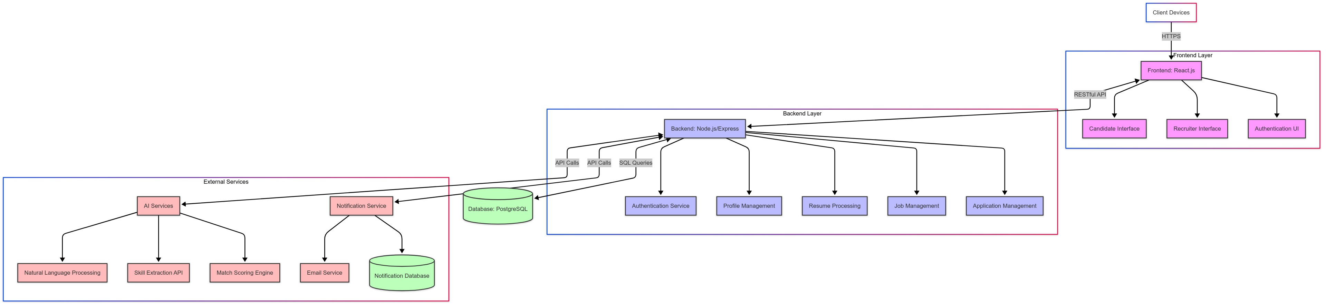

Figure 1: System Architecture Diagram

0.9 Design Strategy

The design strategy prioritizes modularity, scalability, and maintainability:

• Frontend: React.js is chosen for its component-based architecture, enabling reusable

UI elements and efficient state management.

• Backend: Node.js with Express.js supports asynchronous operations, ideal for handling concurrent user requests.

• Database: PostgreSQL ensures robust data management with ACID compliance for user and job data.

• Authentication: JSON Web Tokens (JWT) provide secure, stateless session man- agement.

• AI Integration: External AI services reduce development time while leveraging advanced NLP capabilities.

• Design Patterns: Model-View-Controller (MVC) for frontend; layered architec- ture (presentation, business logic, data access) for backend.

0.10 Detailed System Design

0.10.1 Database Design

The database design includes the following entities and their relationships:

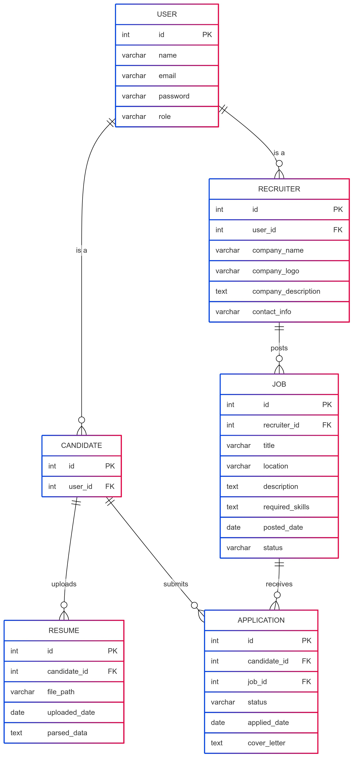

Figure 2: Entity Relationship Diagram

6

Data Dictionary

• User Table

|  |  |  |  |  |  |
| --- | --- | --- | --- | --- | --- |
| Column Name | Description | Data Type | Length | Null? | Default |
| id | Unique identifier | Integer | 11 | No | Auto Increme |
| name | User’s name | Varchar | 255 | No | NULL |
| email | User’s email | Varchar | 255 | No | NULL |
| password | Hashed password | Varchar | 255 | No | NULL |
| role | User role (Candidate/Recruiter) | Varchar | 50 | No | NULL |

Table 4: User Table

• Candidate Table

Key Ty

|  |  |  |  |  |  |  |
| --- | --- | --- | --- | --- | --- | --- |
| Column Name | Description | Data Type | Length | Null? | Default |  |
| id | Unique identifier | Integer | 11 | No | Auto Increment | Primary |
| user id | Foreign key to User | Integer | 11 | No | NULL | Foreign |

Table 5: Candidate Table

• Recruiter Table

|  |  |  |  |  |  |
| --- | --- | --- | --- | --- | --- |
| Column Name | Description | Data Type | Length | Null? | Default |
| id | Unique identifier | Integer | 11 | No | Auto Increment |
| user id | Foreign key to User | Integer | 11 | No | NULL |
| company name | Company name | Varchar | 255 | No | NULL |
| company logo | Logo file path | Varchar | 255 | Yes | NULL |
| company description | Company details | Text | - | Yes | NULL |
| contact info | Contact details | Varchar | 255 | Yes | NULL |

Table 6: Recruiter Table

• Job Table

|  |  |  |  |  |  |
| --- | --- | --- | --- | --- | --- |
| Column Name | Description | Data Type | Length | Null? | Default |
| id | Unique identifier | Integer | 11 | No | Auto Increment |
| recruiter id | Foreign key to Recruiter | Integer | 11 | No | NULL |
| title | Job title | Varchar | 255 | No | NULL |
| location | Job location | Varchar | 255 | No | NULL |
| description | Job description | Text | - | No | NULL |
| required skills | Skills required | Text | - | No | NULL |
| posted date | Date posted | Date | - | No | NULL |
| status | Job status (Active/Inactive) | Varchar | 50 | No | Active |

Table 7: Job Table

• Resume Table

|  |  |  |  |  |  |
| --- | --- | --- | --- | --- | --- |
| Column Name | Description | Data Type | Length | Null? | Default |
| id | Unique identifier | Integer | 11 | No | Auto Increment |
| candidate id | Foreign key to Candidate | Integer | 11 | No | NULL |
| file path | Resume file path | Varchar | 255 | No | NULL |
| uploaded date | Date uploaded | Date | - | No | NULL |
| parsed data | Parsed resume data (JSON) | Text | - | Yes | NULL |

Table 8: Resume Table

• Application Table

|  |  |  |  |  |  |
| --- | --- | --- | --- | --- | --- |
| Column Name | Description | Data Type | Length | Null? | Default |
| id | Unique identifier | Integer | 11 | No | Auto Increment |
| candidate id | Foreign key to Candidate | Integer | 11 | No | NULL |
| job id | Foreign key to Job | Integer | 11 | No | NULL |
| status | Application status | Varchar | 50 | No | Applied |
| applied date | Date applied | Date | - | No | NULL |
| cover letter | Cover letter text | Text | - | Yes | NULL |

Table 9: Application Table

0.10.2 Application Design

The application design includes sequence diagrams for key use cases and a data flow diagram to illustrate system interactions.

Sequence Diagrams

• Candidate Uploads Resume

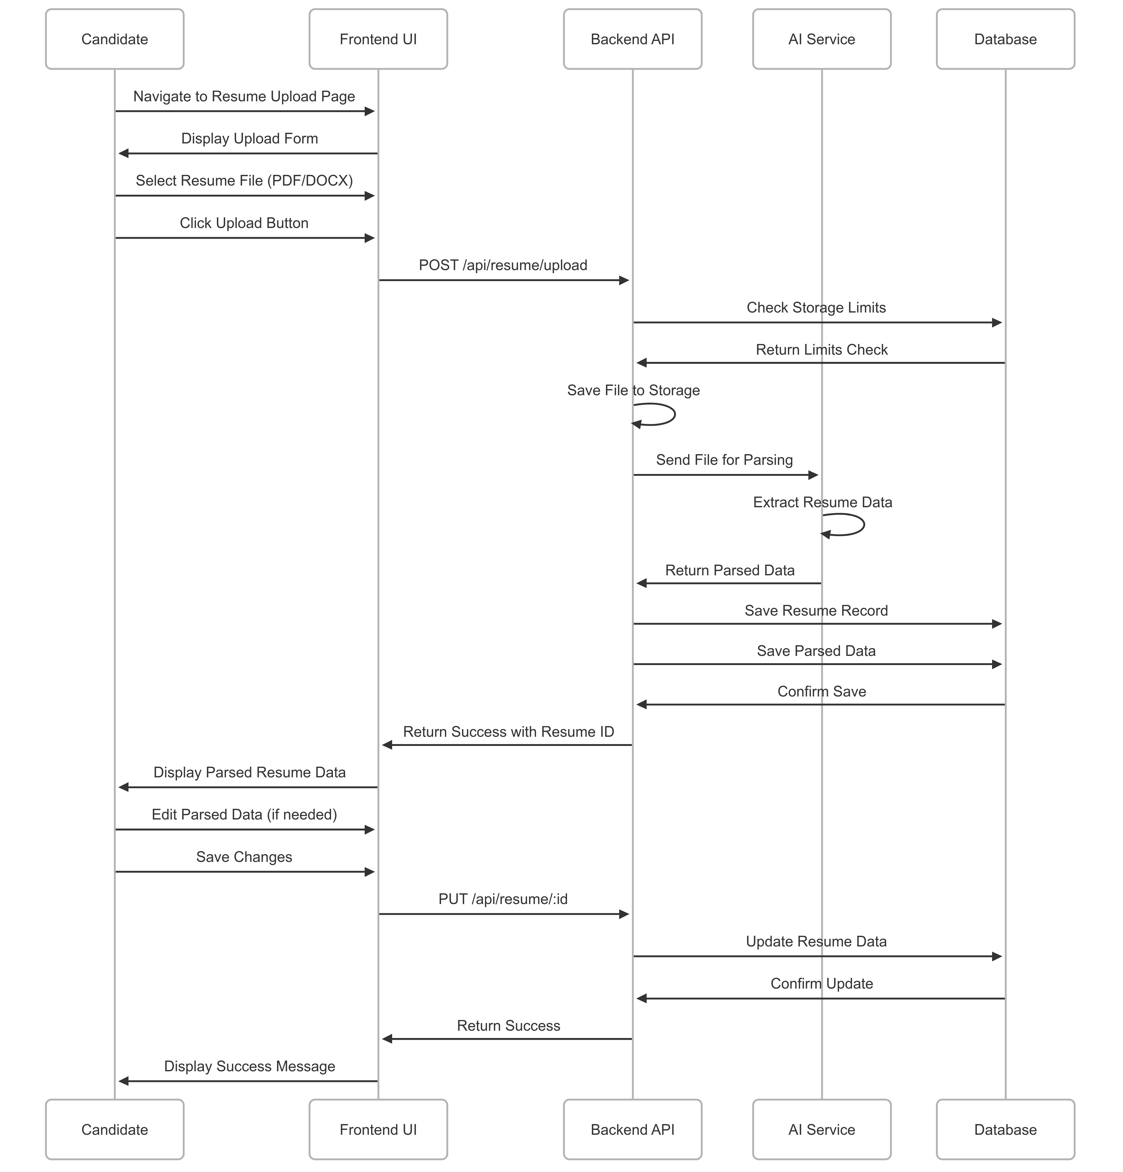

Figure 3: Sequence Diagram: Candidate Uploads Resume

• Recruiter Posts a Job

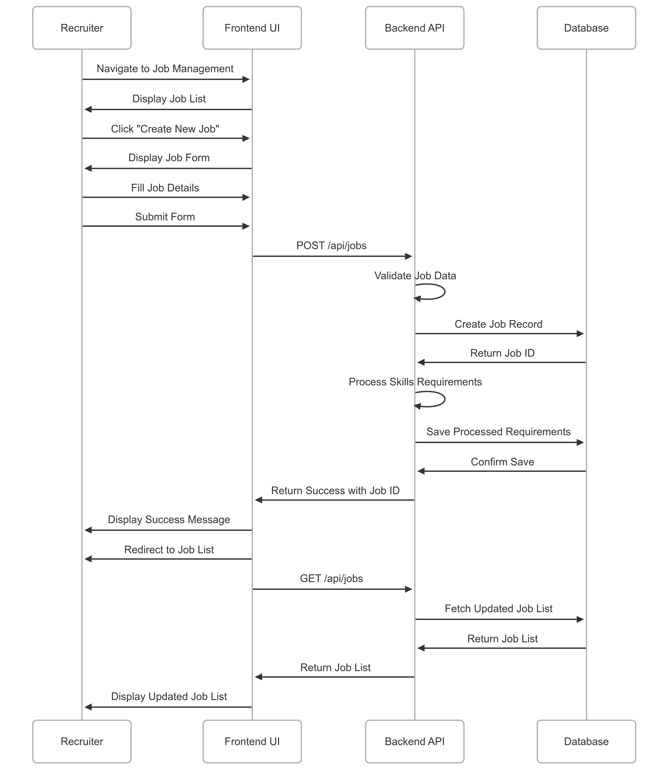

Figure 4: Sequence Diagram: Recruiter Posts a Job

• Candidate Applies for a Job

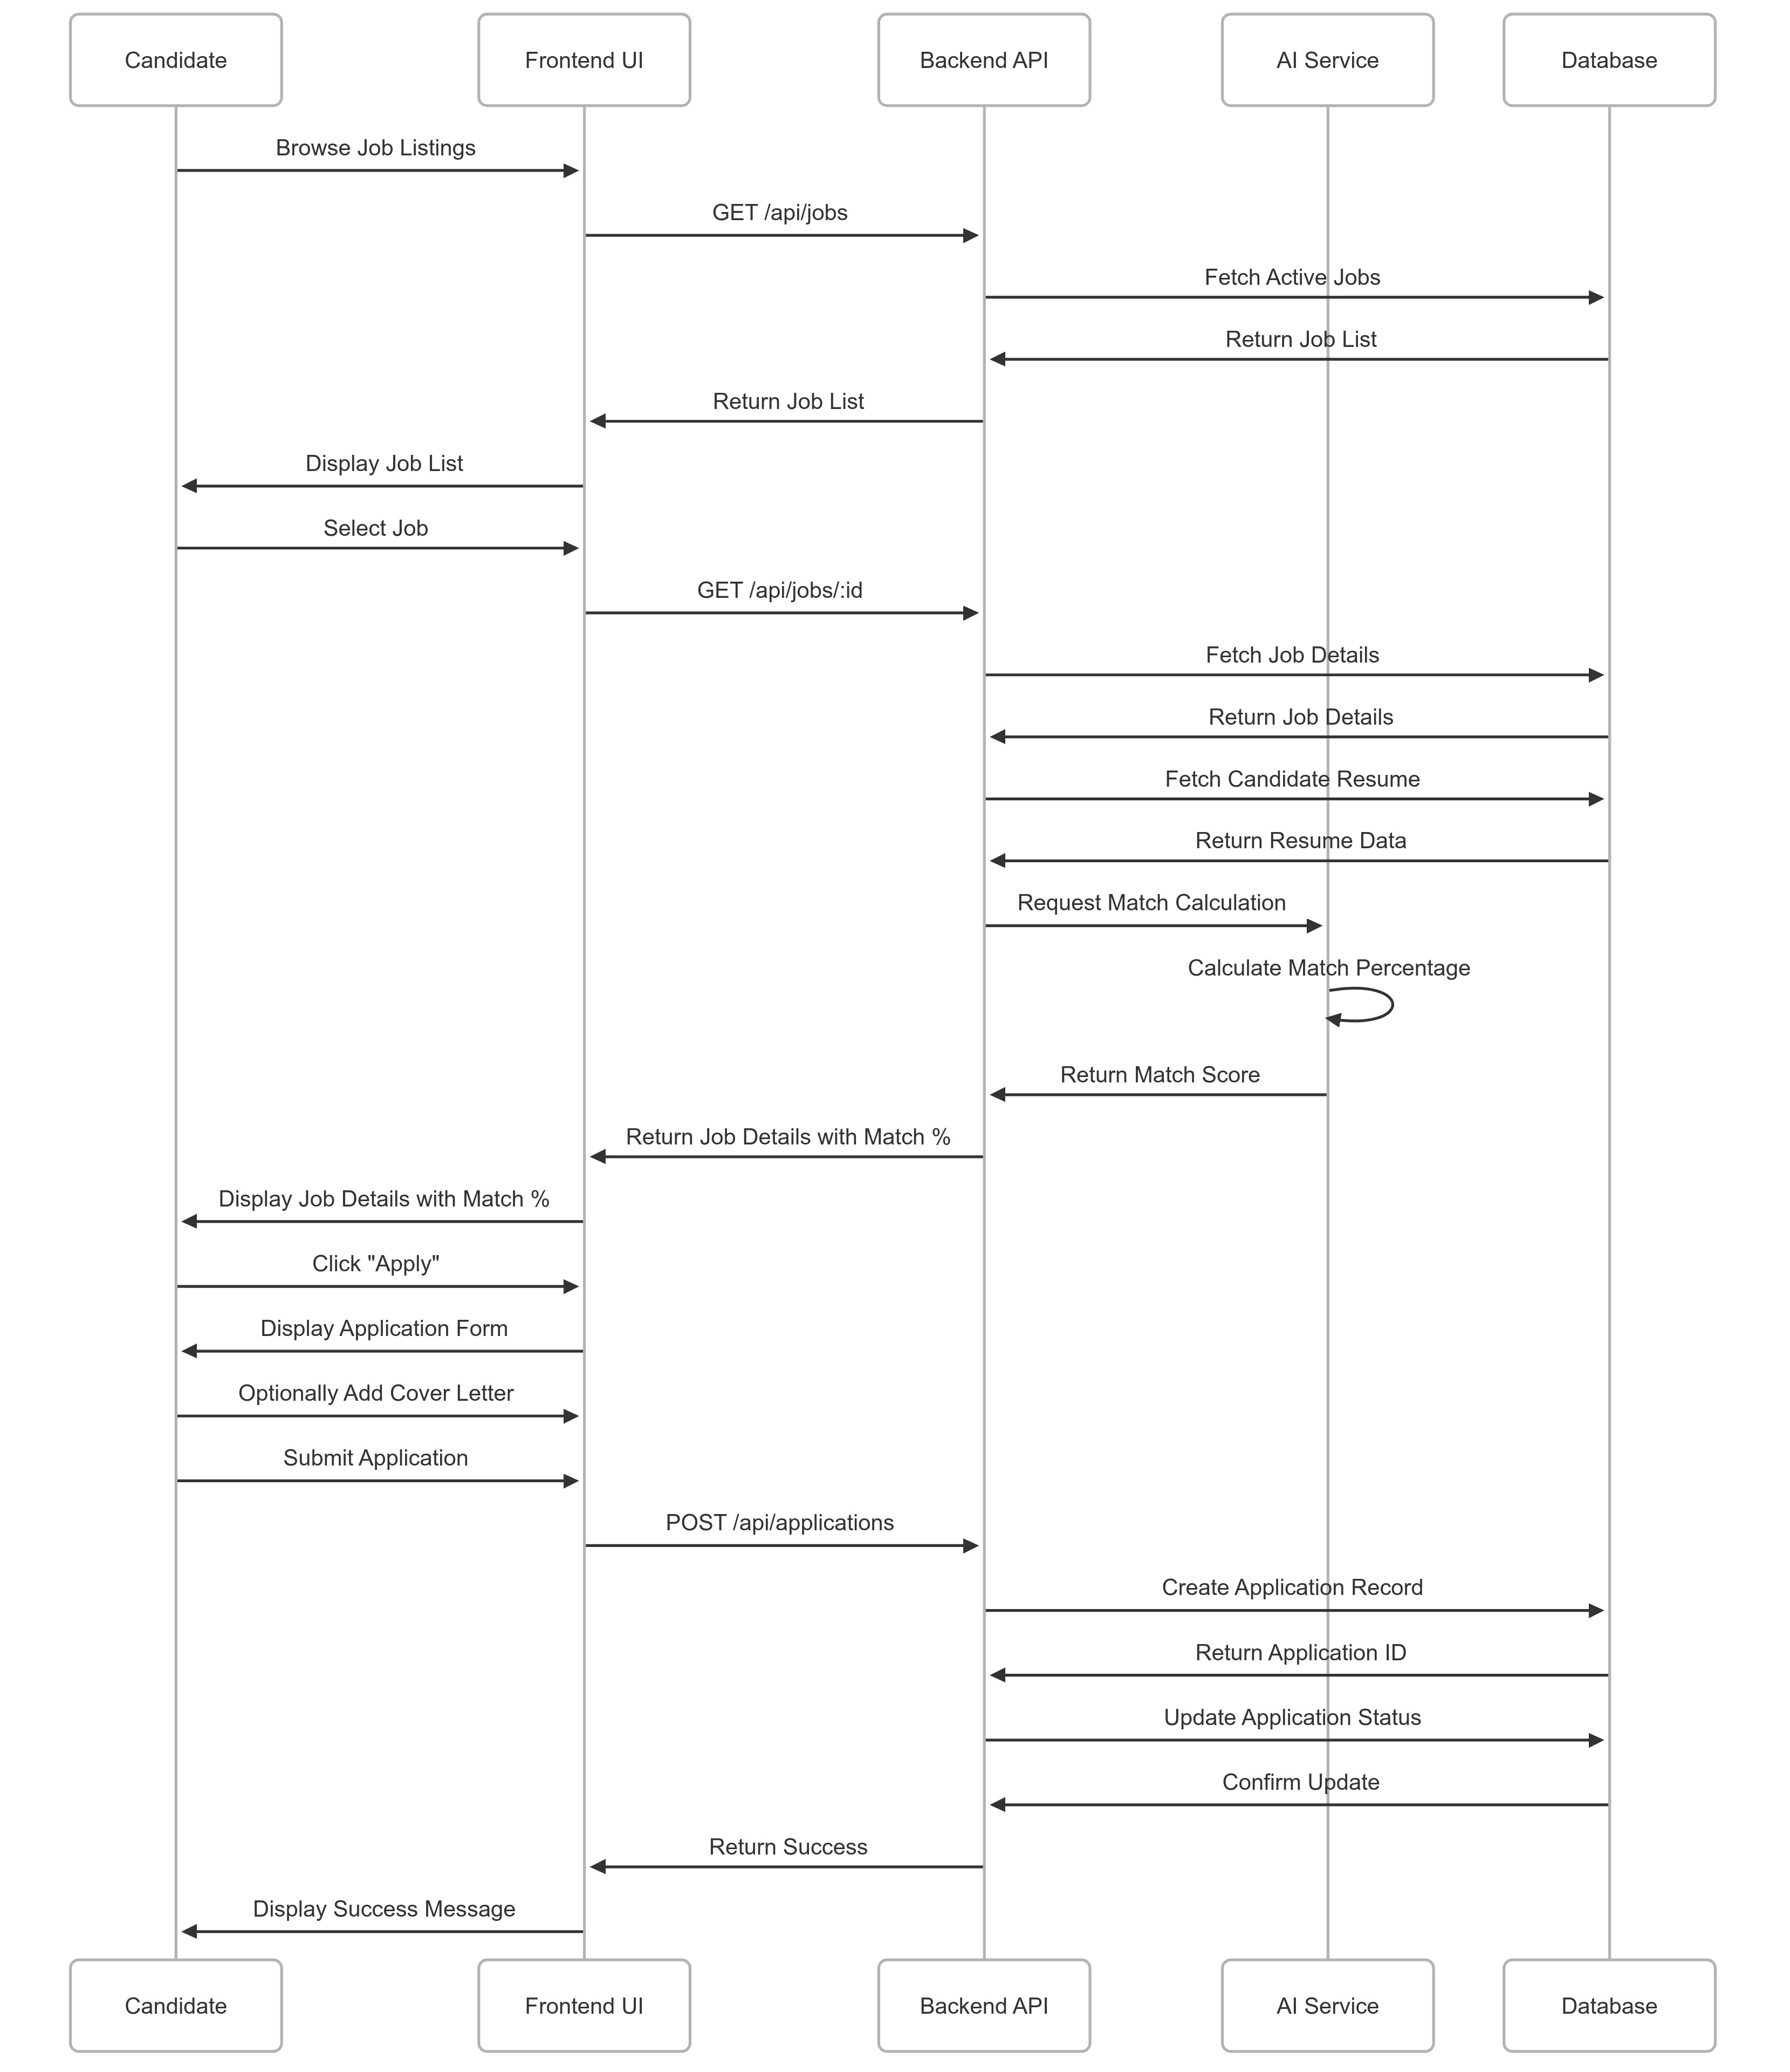

Figure 5: Sequence Diagram: Candidate Applies for a Job

11

Data Flow Diagram (DFD Level 1)

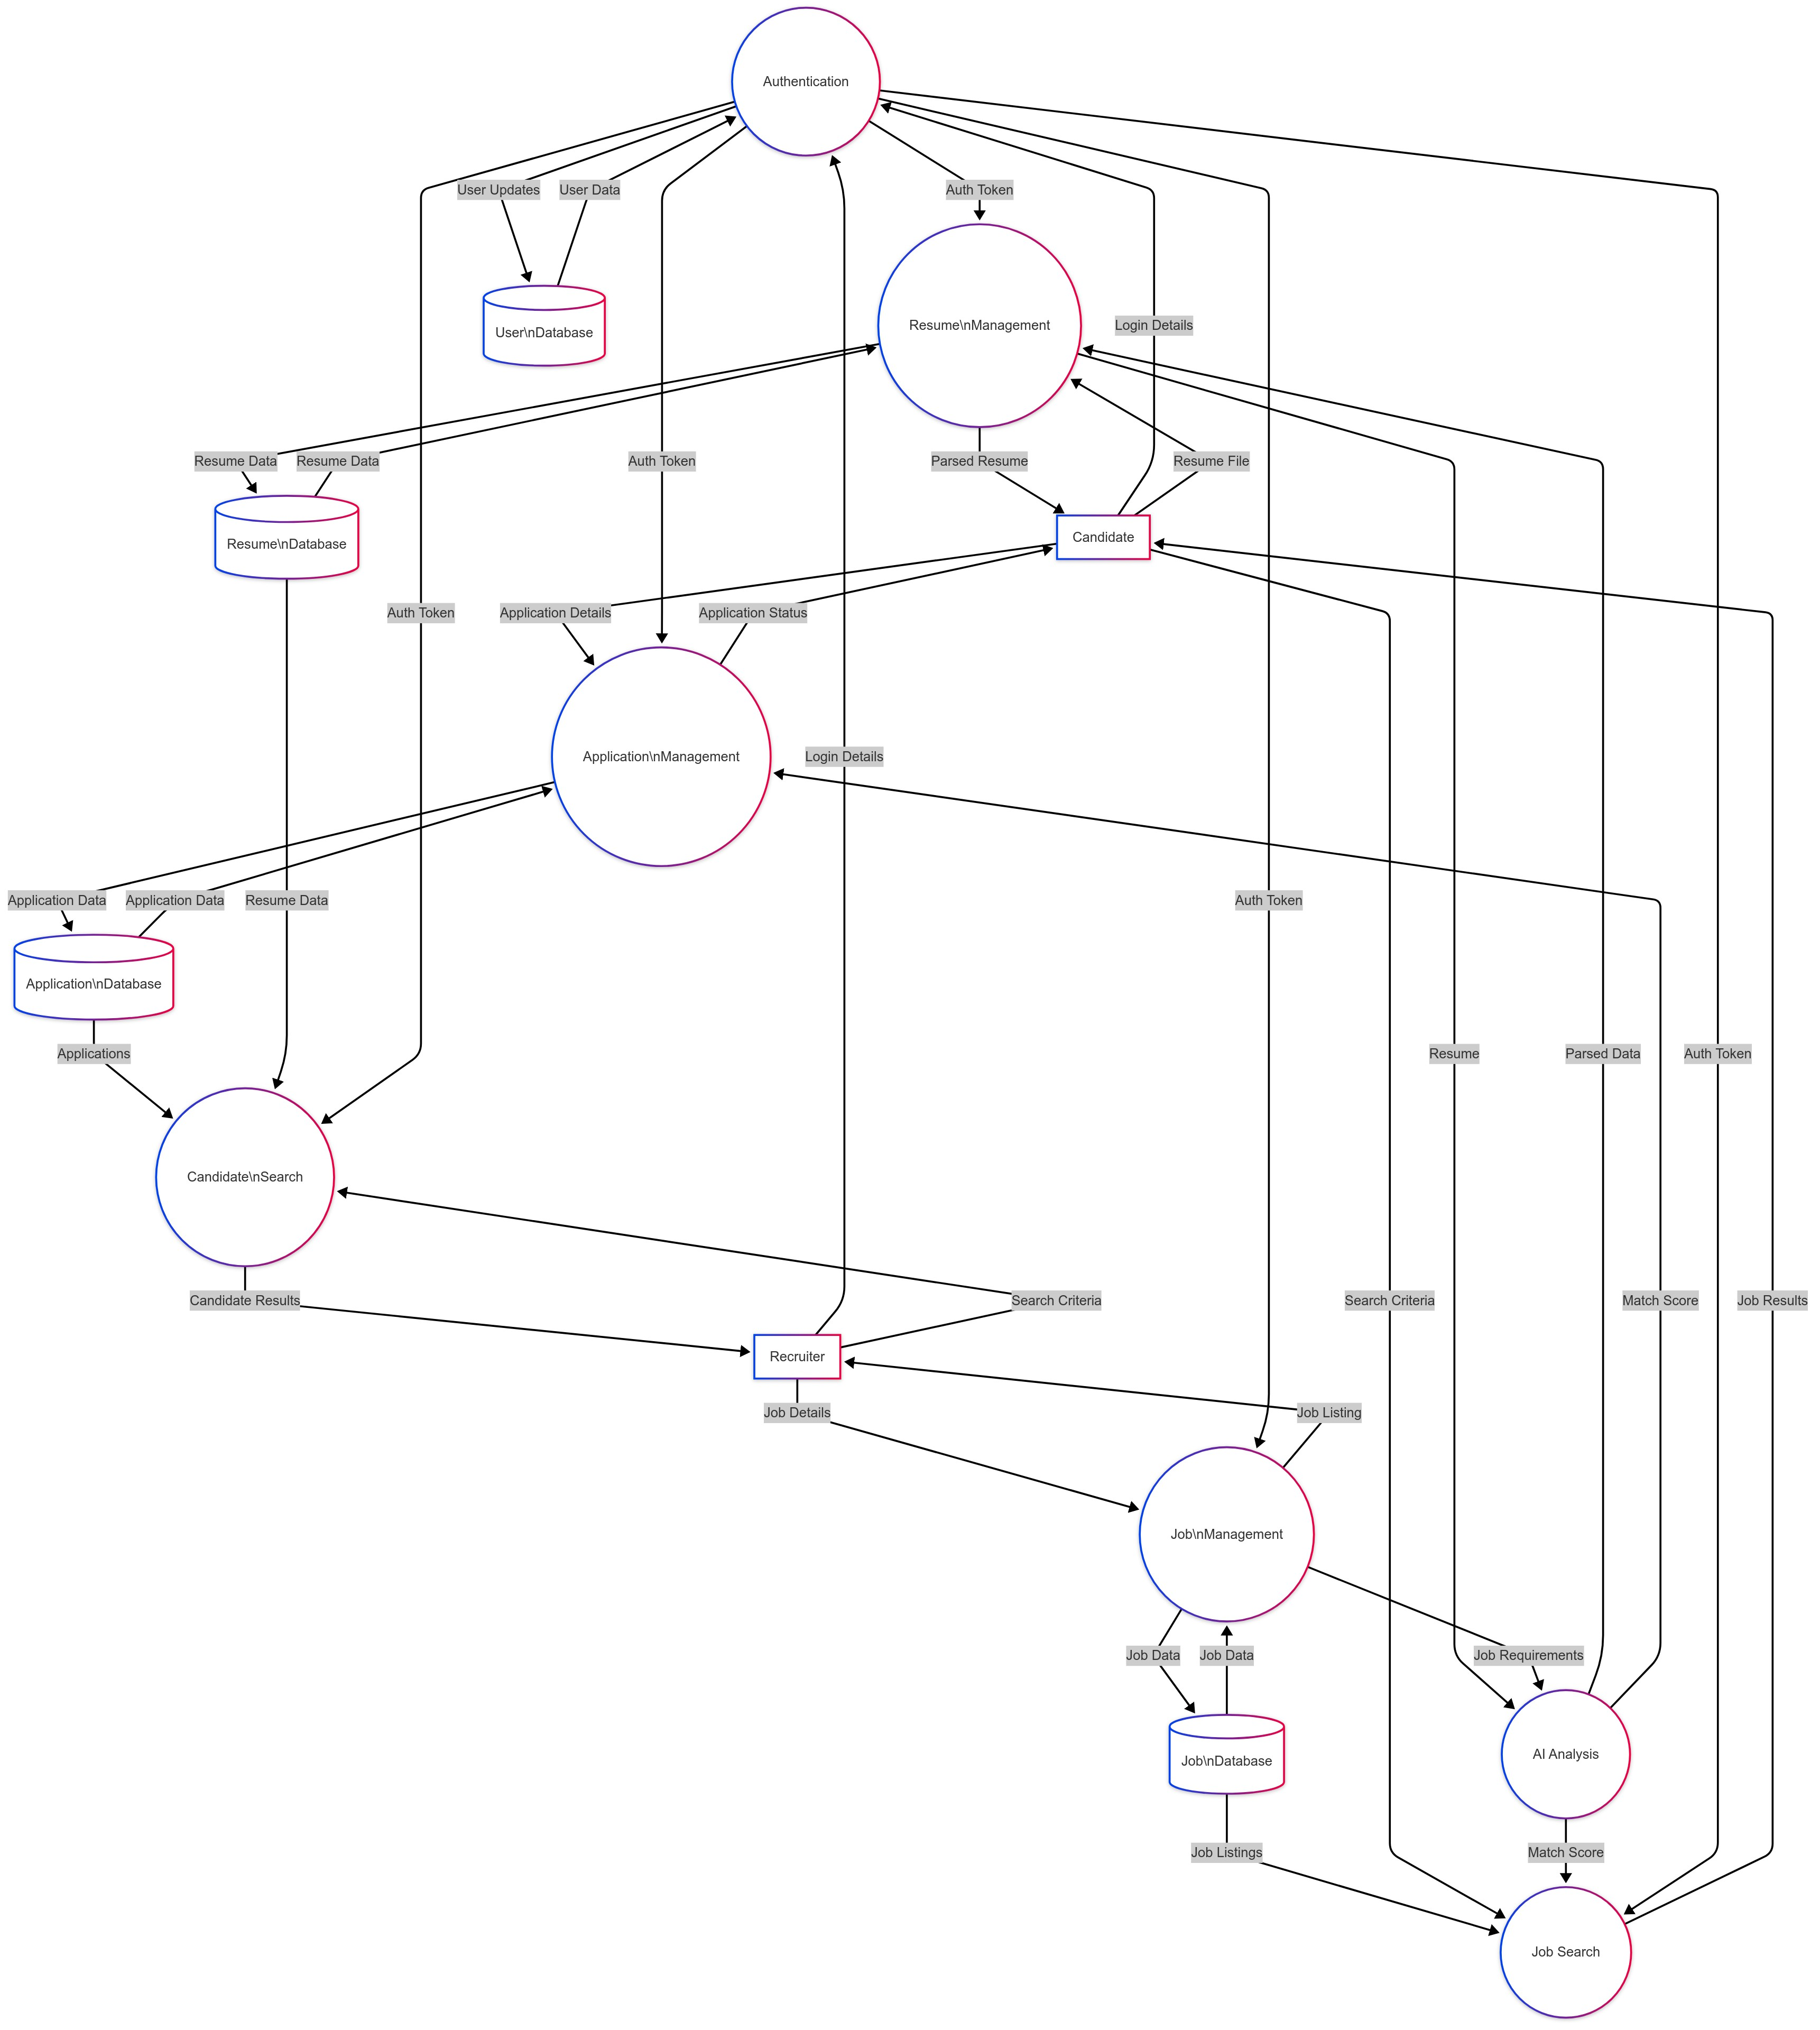

Figure 6: Data Flow Diagram (Level 1)

0.11 References

• Software Requirements Specification (SRS) for Resume Parser System, Version 1.0, May 5, 2025

• Design Patterns: Elements of Reusable Object-Oriented Software, Erich Gamma, Richard Helm, Ralph Johnson, John Vlissides, 1994

0.12 Appendices

This section is reserved for additional information, such as detailed API documentation, UML diagrams, or other supporting materials, as required by the project.